Win Rate Prediction in Rainbow Six Siege

**Part 1: Introduction and Motivation**

Rainbow Six Siege is an extremely competitive first person shooter, real time strategy video game created in 2015, developed by Ubisoft. Almost like a hybrid of Call of Duty and Overwatch, this game is multi-leveled in terms of gameplay, and requires a vast amount of skill in order to be the best.

Each match consists of two roles: Attackers and Defenders, having teams of 5 switch off between roles every 3 rounds. The match is won once a team gets to 4 round wins, winning by atleast 2. Overtime is initiated if the score is tied 3-3, in which case its first to 5 round wins. These matches take place over a variety of 'maps', or game environments, and each team has certain 'Operators' or in game characters to play as. Attacker Operators and Defender Operators are completely different in their special abilities, guns, and speed/armor statistics. This was just an overview of Rainbow Six Siege, however a detailed description of the game can be found at this link: [RainbowSixSiege](https://www.ubisoft.com/en-us/game/rainbow-six/siege), and video description at: RainbowSixSiege Youtube

Competitive video games are all centered around a finite and sensitive balance in their game mechanics and rules; meaning that ideally, nothing is either too overpowered to guarantee a win, or too underpowered and completely useless. To maintain this balance, games are often updated frequently to fine tune these mechanics to ensure proper balance at all times; or at least as close as game developers can make it. Because of this, it would be very useful to model if a game was in fact truly balanced or not, and which mechanics should be changed, or completely removed from the game. An example of an extreme imbalance might be for a given map, the Attackers win 90% of the rounds played. This would mean that if your team were the Attackers, and keeping skill level between teams constant, that your team almost had a guaranteed win.

Fortunately, Ubisoft has released two datasets in 2017 of operator and map statistics, so in this project I will utilize both to determine which game mechanics, if any, are not truly balanced. To accomplish this task, I will be predicting the Win/Loss Ratio for given Attacker and Defender Operators on a given map, as well as Win/Loss Ratio for Attackers and Defenders in general, in a given map.

**Part 2: Research Question**

Partly discussed in the introduction, the main research question for this project is: can we accurately predict the Win Rate of certain operators, as well as the Win/Loss ratio of Attackers and Defenders in general, per map. To do this, the process of Multiple Linear Regression will be used, because of the vast amount of explanatory variables in both dataset.

Both datasets were collected from Ubisoft’s Rainbow Six Siege webpage, with the data being compiled from 2015-2017, and formally released to the public in 2017. This was particularly awesome, because usually game developer studios never release in game data to the public; but Ubisoft saw the value in gathering outsider insight and interpretation to achieve the ultimate goal of a competitive and balanced game.

**Part 3: Literature Review**

But why does this research question hold any value? Why should Ubisoft care if their game is completely balanced or not? By ensuring a balanced game, Ubisoft retains its player-base, by keeping the game as competitive as possible. Data Science is a very useful tool in the Video Game industry, and is used in situations just as this, to optimize the potential of the game in question. In an extremely competitive market, Game Studios all over the world have used internal data from millions of players/users in order to infer decisions that would affect gameplay and experience. Recognizing that a fine-tuned balance is essential in competitive multiplayer games such as Rainbow Six Siege, it is up to the game developers to implement data-oriented decisions in order to properly sustain that balance.

**Part 4: Cleaning, Preprocessing**

The two datasets released by Ubisoft is divided into: Operator data, and Objectives/Maps data. The explanatory variables are displayed below:

1. Objectives:
   1. platform: PC, XBOX, Playstation 4
   2. Dateid: Date the match was played on
   3. gamemode: Which in game mode was played (Bomb, Hostage, Secure Area)
   4. mapname: Which in game map or environment the match was played on
   5. objectivelocation: Which objective sight was that round of the match played on (There are multiple in each map)
   6. skillrank: What the overall skill ranking of every player in the match was
   7. role: Attacker or Defender
   8. operator: Which operator was picked for that round for a given player
   9. nbwins: Amount of wins that match (0 or 1)
   10. nbkills: Amount of kills that match
   11. nbdeaths: Amount of deaths that match
   12. nbpicks: Amount of rounds played
2. Operators:
   1. platform: PC, XBOX, Playstation 4
   2. Dateid: Date the match was played on
   3. skillrank: Overall skill ranking of every player in the match
   4. role: Attacker or Defender
   5. operator: Which operator was picked for that round for a given player
   6. primaryweapon: Which primary weapon they picked
   7. secondaryweapon: Which secondary weapon they picked
   8. econdarygadget: Which secondary gadget they picked. (Primary gadget is fixed depending on which operator was chosen)
   9. nbwins: Amount of wins that match (0 or 1)
   10. nbkills: Amount of kills that match
   11. nbdeaths: Amount of deaths that match
   12. nbpicks: Amount of rounds played

For these datasets, the only platform is PC. This is because PC gameplay is much more competitive than console gameplay on XBOX or PlayStation, and will serve the most use for this analysis. Additionally, there is 500,000 entries in Operators, and nearly 1,000,000 entries in Objectives, making both datasets quite large.

Starting off, I dropped the columns: ‘dateid’, ‘primaryweapon’, and ‘secondaryweapon’; as weapon loadout combination possibilities for each operator are numerous, and the primary focus is operator Win/Loss ratios as a whole, disregarding weapon loadout. Next, I collapsed rows in the dataframe, grouping them by ‘skillrank’,’role’, and ‘operator’, and then summing the amount of kills, deaths, and picks in each group. Additionally, every observation in both datasets are of player versus player matches (PVP), so I then trimmed the ‘PVP’ string off of the ‘gamemore’ column. Finally, I completely removed the observations that had the RESERVE operator. This is because the RESERVE operator is only played when you do not have any other operator to choose from and play as, and is rarely every played; except in the case of brand new players. After these initial cleaning steps, the data is now ready for Exploratory Data Analysis.

**Part 5: Exploratory Data Analysis (EDA)**

In this section, I create scatter plots, line graphs, and histograms to explore the features of the data, to get further insight before conducting the analysis. The first two charts I decided to graph were Kill/Death ratio vs Win/Loss ratio for each operator for defenders and attackers. Muc like Win/Loss explained previously, Kill/Death ratio, or KD, is the amount of kills divide by the amount of deaths; or how many kills you average per death. A picture containing large

From both charts, we can observe a clear positive correlation between the amount of kills an operator averages per death, and the amount of wins that operator averages per loss, when played. An important domain knowledge indication is that not every operator serves the same purpose or utility in the game. Operators are unofficially divided into subclasses: Anchor, Fragger, and Support. The Anchor’s job is to defend the rest of the team mates, and when on Defense, “anchor” the main objective room by guarding it, and protecting teammates when on attack. The Fragger’s main purpose is just to get as many kills as possible to aid the team, and the Support mainly utilize their gadgets to aid the team. With this in mind, lets observe the different operators for each chart more carefully.

For Attackers, the highest KD ratio operators are: Ash, Hibana, Blackbeard and Twitch. Three out of those 4 operators are Fraggers, with Twitch being Support. The operators with the lowest KD ratio are: Montagne and Blitz, which makes sense, since they are Anchor and Support operators, respectively. It should also be noted that they are the only operators in the game that have riot shields as their primary weapon. For Defenders, Jager, Valkyrie, Caveira and Bandit have the highest KD ratios; again making sense because 3 of them are classified Fraggers, with Valkyrie being Support. The lowest KD ratio operators are: Tachanka, Castle and Mute, all three of which are support operators. Castle and Mute are rarely used since their gadgets/utility are minimal compared to other operators, and Tachanka is borderline useless with his gadget, and is almost never picked; except only to mock the other team because he is so terrible. The Defender’s graph also makes sense and nothing stands out.

A key feature in competitive video games, Rainbow Six Siege included, is the ranking system. The in game ELO ranking system, similar to chess, places you in a category based on your overall ELO rating. Winning matches gains you ELO rating, and losing decreases your ELO rating. The 7 categories of rank include: Unranked, Copper, Bronze, Silver, Gold, Platinum, and Diamond. Subsetted in those categories are yet again a tiered system from 1-4: Gold 4, Gold 3, Gold 2, etc. for all ranks. Once a player advances past the 1 tier of that rank, they advance till the next rank. For example a player would advance to Platinum, after receiving enough ELO to advance from Gold 1. From the histograms shown below, we can see that a majority of the observations in the data are from Silver and Gold players, mainly because there are more of them playing than Copper or Diamond players. There also is a significant drop off in the amount of Platinum players from Gold and again from Platinum to Diamond. This is a perfect illustration of *Skill Gap. Skill Gap* is the gap in skill between players of different ranking, and exponentially increases as you progress. For example, the difference in skill between Copper, Bronze and Silver is pretty linear and not very noticeable. However, the jump in skill from Silver to Gold is very substantial and noticeable, and even more so from Gold to Platinum, and Platinum to Diamond. A Diamond team would most likely never lose to a Gold team because of the vast skill gap. A screenshot of a cell phone

Because not every rank is equally represented in the data, we must standardize the data before we are able to use the scikit library for regression analysis. Additionally, we should want to focus on which players Diamond players pick more often, because their pick rate for operators is more valuable than Copper; for the reason of Skill Gap, and Diamond players being more knowledgeable about the game. Diamond players will pick the best operator for any given situation knowingly, whereas Copper players will more often pick the best operator choice by chance. After standardizing the data, we can now use a scatter-line plot to graph the pick rates for each operator over every rank.

From these two charts, there are a couple key observations that should be noted. Some operators have consistent pick rates across all rankings, whereas some operators fluctuate in pick rate between rankings. For Attackers, the two most commonly picked operators are Hibana and Ash. Their pick rates increase significantly as you increase the ranking from Copper to Diamond, indicating that these characters are most often the best choice. Using domain knowledge about the game myself, this does not surprise me at all because Ash and Hibana have almost no compromises: Their abilities/utility are very beneficial, and their gun selection/customization possibilities are amazing. Another observation if that the operators Fuze and Glaz drop off in pick rate significantly as the ranking progresses. This is because early on those operators might be appealing to newer players because their abilities are easy to learn, but as you learn their counters, and become more skilled with the gameplay, they cease to be of any use to the team; to the point of almost being detrimental. For Defenders, the two highest picked characters are: Jager, and Bandit; for the same reasons of the Attackers: they have 0 compromises. Some operators that decrease in pick rate as you progress rank include: Rook, Caveira, and Mute. This is because for newer and lower ranked players they are extremely useful and powerful to use, but once you learn their counters, their utility and usefulness depletes; indicated by the decrease in pick rate across higher ranks. Additionally, the defender Tachanka is almost never picked because of his useless utility, but only sometimes in given situations or to mock the other team.

From both of these charts, we can infer that the operators: Ash, Jager, Hibana, and Bandit might be slightly unbalanced and a little too powerful. A ‘nerf’ or a manual decrease in utility or operator stats such as damage of their guns, fire rate, etc. may need to be implemented in order to properly balance the gameplay. These datasets are from 2017, three years ago, and do not represent the game at its current state. The noticeable mention to nerfing Jager, Ash, and Bandit were to take away the ACOG attachment for their guns, decreasing the range that they could engage at, and properly nerfing them. This nerf came out after the datasets were released.

Aside from pick rate, I also want to inquire about the Win/Loss ratio per operator. After splitting the data grouped by roles again, and skill ranking, the graphs are shown below:

In these charts, the spread is much less than the pick rate chart. This is partly due to the fact that there are no ties in matches, there is always a winner and a loser. But there are still a couple operators for Attackers and Defenders that win more often than others. These operators being: Blackbeard, Frost, Caveira, Rook, and Valkyrie. Additionally, we see an increasing trend in win rate across rankings. This is because not all matches have teams from the same ranking. Sometimes Diamond players will be on a Platinum averaged team, or vice versa. This trend makes sense, as we’d expect better players to win more often than worse players.

From both sets of charts, we see that certain operators require a ‘Nerf’: decrease in capability to win, and some operators are in need of a ‘Buff’: increase in capability to win; in order to properly balance out gamplay.

The last set of charts that I will create in the EDA portion of the project are: Win rates based on operator and map. The heatmaps illustrated below capture this task:

These two charts are pretty cumbersome, so a deeper investigation is required for proper analysis. Red squares indicate a high Win rate: 52% and 60% for Attackers and Defenders respectively. Blue squares represent a lower Win rate. The y axis is the different maps or game environments in Rainbow Six Siege, and the x axis is each of the operators. The first observation here is that overall, Defenders win more than Attackers. This is because the gameplay is oriented around Defenders; being that Attackers have to bring the fight to Defenders. Because of this, Defender’s win most of the rounds played in the game.

Ideally, a perfectly balanced game would have Attackers and Defenders winning 50% of the time. However, if is shown here that there are a couple of maps where Attackers Win a majority of the time: Favela, House, and Chalet. On the flipside, the maps where Defenders win most of the games are: Bartlett, Bank, and Plane. These two observations would indicate that these maps are not entirely balanced and may favor one role over the other; discrediting true competitive gameplay. It should be noted that some time after these datasets were released, most of the maps above were either re-worked and edited to favor a true balance, or completely removed from the game. The ones that were entirely removed included: House, Favela, Bartlett, and Plane.

Besides looking at the maps aspect, are there any operators that Win at a higher rate across all maps? For Attackers, this would include: Ash, Blackbeard, and Hibana, and for Defenders, this includes: Frost, Valkyrie and Jager. These operators show up on top in almost every chart we have produced, indicating that a change to their gameplay is needed to properly balance them.

**Part 6: Regression Analysis**

In this section, I will focus on developing a model that can accurately predict the win rate of a round between Attackers and Defenders. Because I have many explanatory variables to examine, I will be using the method of Multiple Linear Regression. After splitting the data into a training and testing set, I will implement a technique called: One-Hot-Encoding; to transform categorical variables in the dataset to be usable for the Regression Library in Scikit. First, I will add Kill/Death Ratio into the Operators data, as well as remove nbwins, nbkills, nbdeaths, and nbpicks.

Both Attackers and Defenders seem to be following an almost normal distribution around 0.5-0.55. This would indicate that most operators Win and Lose about 50% of the time, where others Win and Lose a little more or less. With both models performing well, so the next step is to conduct an F-test for Goodness of Fit. After conducting an F-test, both models passed with a P-value being less than 0.05, indicating strong models for both Attackering Operators and Defending Operators.

Next for the objectives dataset, the same process is implemented. Both charts for Attackers and Defenders are produced below, with both models passing the F-test with P-values less than 0.05.

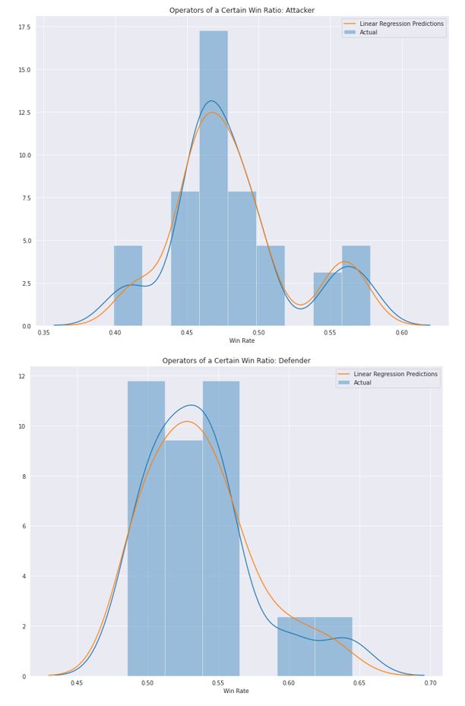

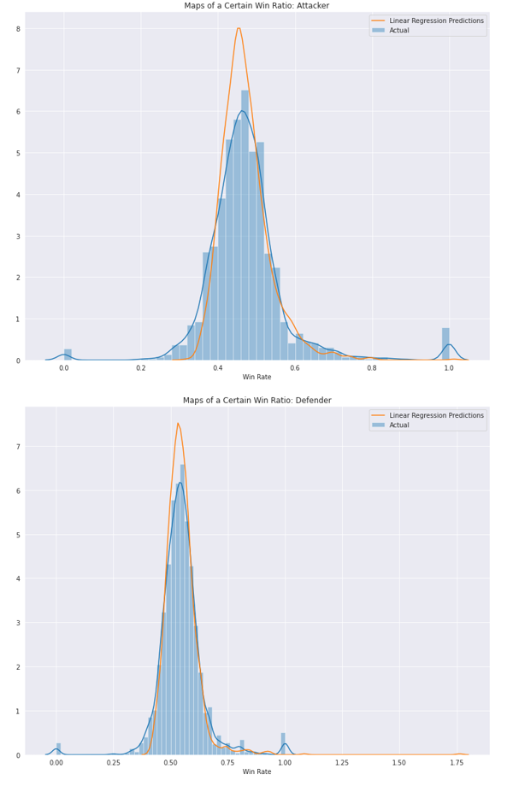

From these two charts, we can see that there are some maps that are won and lost more frequently by Attacks or Defenders, as well as some operators winning and losing more often than others. From this analysis, it is clear that Rainbow Six Siege at the state that the data was released in is not entirely balanced and must be fine tuned in order to be truly competitive.

**Part 7: Conclusion**

Over the course of this project, the concept of balance in competitive video games was visited through Rainbow Six Siege. Through the process of multiple linear regression, we were able to accurately predict the Win Rate of different operator characters in the game as well as the Win Rates for Attackers and Defenders for each map. Through EDA, we explored pick rates of different operators, KD ratios of different operators throughout different rank ranges, as well as the WL ratios and saw a positive correlation between receiving kills and wins. Additionally, there were a few operators on Attack and Defense where their pick rates were higher and lower than most, and Win/Loss ratios also higher. This might indicate that there is some imbalance in how they operate compared to the rest. Finally, the heatmaps we produced showed that certain maps had Attackers or Defenders winning most of the time; around 55-60%. These maps will need to be reworked/altered, or completely taken out of the game to keep Rainbow Six Siege perfectly competitive, and as close to balanced as possible. If these changes are implemented, then the game will continue to be one of the most fun and competitive shooters on the market.